***EXPERIMENT NO- 01***

**AIM:** Study of Network media, cables, and devices and Cable Construction.

**OBJECTIVE:** To study about different types of network media, cables and devices and cable constructions.

**DESCRIPTION:**

**NETWORK MEDIA (TRANSMISSIONMEDIA):**

Network media refers to the communication channels used to interconnect nodes on a computer network. Typical examples of network media include copper coaxial cable, copper twisted pair cables and optical fibre cables used in wired networks, and radio waves used in wireless data communications networks.

Network medium is the actual physical path between the transmitter and the receiver i.e., It is the channel through which data is sent from one place to another. It is classified into two types:

i.Guided media(wired)

ii.Unguided media(wireless)

**GUIDED MEDIA:** Guided media is also called as wired media. It uses a system that guides the data signals along a specific path. Signals being transmitted are directed and confined in a narrow pathway by using physical links.

**Features:** High speed, secure, used for comparatively shorter distances

There are 3 types of guided media:

**a) Twisted pair cable:** Twisted pair is a physical media made up of a pair of cables twisted with each other. A twisted pair cable is cheap as compared to other transmission media. Installation of the twisted pair cable is easy, and it is a lightweight cable. The frequency range for twisted pair cable is from 0 to 3. 5KHz.A twisted pair consists of two insulated copper wires arranged in a regular spiral pattern. The degree of reduction in noise interference is determined by the number of turns per foot. Increasing the number of turns per foot decreases noise interference

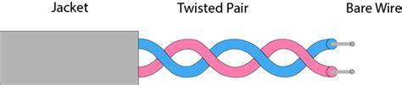

Twisted pair cable is of two types:

**Shielded twisted pair cable:**

It consists of special jacket to block external interface. It is used in fast data rate Ethernet and in voice and data channels of telephone lines. It is bulky.

**Characteristics of Shielded Twisted Pair:**

o The cost of the shielded twisted pair cable is not very high and not verylow.

o An installation of STP is easy.

o It has higher capacity as compared to unshielded twisted pair cable.

o It has a higher attenuation.

o It is shielded that provides the higher data transmission rate.

**Disadvantages**

o It is more expensive as compared to UTP and coaxial cable.

o It has a higher attenuation rate

There are 3 types of guided media:

**Un Shielded Twisted pair cable:**

This type of cable has the ability to block interface and does not depend on a physical shield for this purpose.

**Advantages:**

o Least expensive.

o Easy to install

o short distance transmission due to attenuation

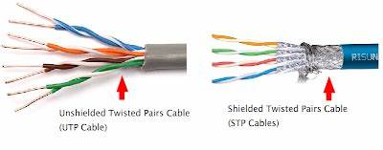

**b) Coaxial cable:**

It has an outer plastic covering containing 2 parallel conductors each having a separate insulated protection cover. The coaxial cable transmits information in 2 modes:

1) Baseband Mode - dedicated cable bandwidth

2) Broadband mode - bandwidth is split into separate ranges

Cable TV ‘s and analog television networks use coaxial cables. They transmit signals over large distances at higher speed as compared to twisted cables.

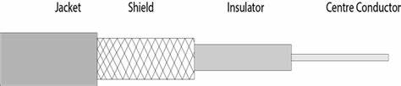

**Advantages:**

1. High Bandwidth

2. Better noise immunity

3. Easy to install and expand

4. Inexpensive

**c) Optical Fiber:**

It uses the concept of reflection of light through a core made up of glass or plastic. It is a transparent and flexible fiber made up of glass, which carries information in the form of light pulses from one end to another. Fiber optics is used for long distance and high-performance network. Used in internet, telephone and television. Core is surrounded by less dense glass or plastic covering called the cladding. Used to transfer large volumes of data. It can be uni-directional or bi-directional.

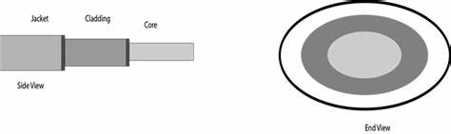

**Basic elements of Fiber optic cable:**

o Core: The optical fiber consists of a narrow strand of glass or plastic known as a core. A core is a light transmission area of the fiber. The more the area of the core, the more light will be transmitted into thefibre.

o Cladding: The concentric layer of glass is known as cladding. The main functionality of the cladding is to provide the lower refractive index at the core interface as to cause the reflection within the core so that the light waves are transmitted through thefibre.

o Jacket: The protective coating consisting of plastic is known as a jacket. The main purpose of a jacket is to preserve the fiber strength, absorb shock and extra fiberprotection.

**Advantages of Optical Fiber**

Optical fiber is fast replacing copper wires because of these advantages that it offers:-

• High bandwidth

• Immune to electromagnetic interference

• Suitable for industrial and noisy areas

• Signals carrying data can travel long distances without weakening

**Disadvantages of Optical Fibre**

Despite long segment lengths and high bandwidth, using optical fibre may not be a viable option for every one due to these disadvantages –

• Optical fibre cables are expensive

• Sophisticated technology required for manufacturing, installing and maintaining optical fibre cables • Light waves are unidirectional, so two frequencies are required for full duplex transmission

**ii) UNGUIDEDMEDIA**

An unguided transmission transmits the electromagnetic waves without using any physical medium. Therefore, it is also known as wireless transmission. In unguided media, air is the media through which the electromagnetic energy can flow easily. Unguided transmission is broadly classified into three categories:

**i) Radio waves**: Radio waves are electromagnetic waves and are omnidirectional. When an antenna transports radio waves they are propagated in all directions in free space which means the sending and receiving antennas do not have to be aligned that is any receiving antenna can receive that transmitted wave. The frequency of radio waves about 30 hertz (Hz) to 300 gigahertz (GHz) and like all other electromagnetic waves radio waves travel at the speed of light in vacuum.

**Applications of Radio waves**

• These waves are omnidirectional so they are useful for multicasting in which one sender but many receivers.

• Examples of radio waves are television, AM and FM radio, cordless phones and paging.

**Advantages and disadvantages**

• Radio waves are easy to generate and penetrate buildings also can travel long distances.

• Radio waves cover a large area and can penetrate the buildings. By this, an AM radio can receive signals inside a building.

• This can also be disadvantageous because we cannot isolate a communication just inside or outside a building. Cause of this, governments strictly legislate the use of radio transmitters.

**ii) Microwaves**: Micro Waves includes a line-of-sight transmission that is the sending and receiving antennas that need to be properly aligned with each other. The distance is directly proportional to the height of the antenna which is covered by the signal. In mobile phone communication and television distribution, these are majorly used.

**Applications of Micro Waves**

Due to the unidirectional properties of Micro Waves, they are very useful when unicast (one-to-one) communication is needed between the sender and the receiver. Cellular phones, satellite networks, and wireless LANs are using Micro Waves.

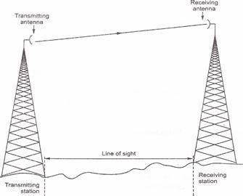

Two types of Microwave Transmission are as follows,

1. Terrestrial Microwave

2. Satellite Microwave

**ii) Infrared waves:**

The frequency of Infrared waves is about 300 GHz to 430 THz, which can be used for short-range communication. Infrared waves of high frequencies cannot penetrate walls. This characteristic of Infrared waves prevents interference between one system and another. This means a short-range communication system in a room cannot be affected by another system in the adjacent room.

If we are using the infrared remote control, we do not interfere with the use of the remote by our neighbours. However, by this characteristic, infrared signals become useless for long-range communication. Also, we cannot use infrared waves outside a building because the sun's rays contain infrared waves that can interfere with communication.

**Characteristics of infrared waves**

• This type of wide bandwidth can be used to transmit digital data with a very high data rate.

• The Infrared Data Association (IrDA) has established standards for using these signals for communication between devices such as keyboards, mouse, PCs, and printers and it is also responsible for sponsoring the use of infrared waves.

• This type of communication provides better security with minimum interference.

**NETWORKDEVICES**

Hardware devices that are used to connect computers, printers, fax machines and other electronic devices to a network are called network devices. These devices transfer data in a fast, secure and correct way over same or different networks. Network devices may be inter-network or intra-network. Some devices are installed on the device, like NIC card or RJ45 connector, whereas some are part of the network, like router, switch, etc. Let us explore some of these devices in greater detail.

**1. REPEATER**

A repeater operates at the physical layer. Its job is to regenerate the signal over the same network before the signal becomes too weak or corrupted so as to extend the length to which the signal can be transmitted over the same network. An important point to be noted about repeaters is that they do not amplify the signal. When the signal becomes weak, they copy the signal bit by bit and regenerate it at the original strength. It is a 2-port device.

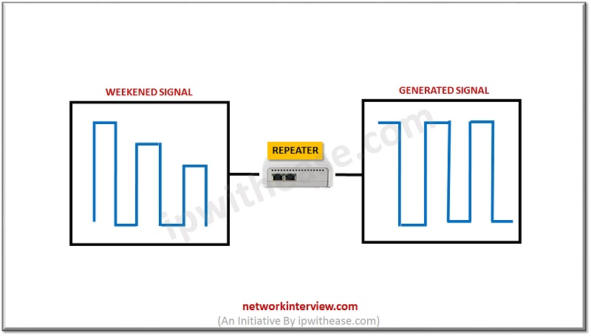Repeaters are network devices operating at physical layer of the OSI model that amplify or regenerate an incoming signal before retransmitting it. They are incorporated in networks to expand its coverage area. They are also known as signal boosters.

**2. HUB**

A hub is basically a multiport repeater. A hub connects multiple wires coming from different branches, for example, the connector in star topology which connects different stations.

Hubs cannot filter data, so data packets are sent to all connected devices. In other words, collision domain of all hosts connected through Hub remains one. Also, they do not have the intelligence to find out best path for data packets which leads to inefficiencies and wastage.

**Types of Hub**

• **Active Hub**: -These are the hubs which have their own power supply and can clean, boost, and relay the signal along with the network. It serves both as a repeater as well as wiring centre. These are used to extend the maximum distance between nodes.

• **Passive Hub**: -These are the hubs which collect wiring from nodes and power supply from active hub. These hubs relay signals onto the network without cleaning and boosting them and can‘t be used to extend the distance between nodes.

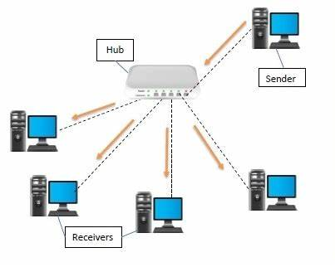**• Intelligent Hub**: -It work like active hubs and include remote management capabilities. They also provide flexible data rates to network devices. It also enables an administrator tomonitor the traffic passing through the hub and to configure each port in thehub.

**3. BRIDGE**

A bridge operates at data link layer. A bridge is a repeater, with add on the functionality of filtering content by reading the MAC addresses of source and destination. It is also used for interconnecting two LANs working on the same protocol. It has a single input and single output port, thus making it a 2-port device.

**Types of Bridges**

**• Transparent Bridges**: -These are the bridge in which the stations are completely unaware of the bridge ‘s existence i.e., whether or not a bridge is added or deleted from the network, reconfiguration of the stations is unnecessary. These bridges make use of two processes i.e., Bridge forwarding and bridge learning.

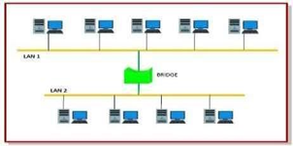**• Source Routing Bridges**: -In these bridges, routing operation is performed by source station and the frame specifies which route to follow. The host can discover frame by sending a special frame called discovery frame, which spreads through the entire network using all possible paths to destination.

**4. TWO LAYERSWITCH**

A layer 2 switch is a type of network switch or device that works on the data link layer (OSI Layer 2) and utilizes MAC Address to determine the path through where the frames are to be forwarded. It uses hardware-based switching techniques to connect and transmit data in a local area network (LAN).

A layer 2 switch can also be referred to as a multiport bridge. A layer 2 switch is primarily responsible for transporting data on a physical layer and in performing error checking on each transmitted and received frame. A layer 2 switch requires MAC address of NIC on each network node to transmit data. They learn MAC addresses automatically by copying MAC address of each frame received, or listening to devices on the network and maintaining their MAC address in a forwarding table. This also enables a layer 2 switch to send frames quickly to destination nodes. However, like other layer switches (3,4 onwards), a layer 2 switch cannot transmit packet on IP addresses and don‘t have any mechanism to prioritize packets based on sending/receiving application.

**5. THREE LAYERSWITCH**

A layer 3 switch combines the functionality of a switch and a router. It acts as a switch to connect devices that are on the same subnet or virtual LAN at lightning speeds and has IP routing intelligence built into it to double up as a router. It can support routing protocols, inspect incoming packets, and can even make routing decisions based on the source and destination addresses. This is how a layer 3 switch acts as both a switch and a router. Often referred to as a multilayer switch, a layer 3 switch adds a ton of flexibility to network.

**Features of a layer 3 switch**

• Comes with 24 Ethernet ports, but no WAN interface.

• Acts as a switch to connect devices within the same subnet.

• Switching algorithm is simple and is the same for most routed protocols.

• Performs on two OSI layers — layer 2 and layer3.

Originally, layer 3 switches were conceived to improve routing performance on large networks, especially corporate intranets. To understand the purpose, let ‘s step back a bit in time to see how these switches evolved.

Layer 2 switches work well when there is low to medium traffic in VLANs. But these switches would hang when traffic increased. So, it became necessary to augment layer 2‘s functionality.

One option was to use a router instead of a switch, but then routers are slower than switches, so this could lead to slower performance.

**CABLECONSTRUCTION**

A cable used for the transmission and distribution of electrical energy is called electrical power cable. Power cable consists two or more electrical conductors join with an over sheath. It is used for the transmission of extra high voltages in a place where overhead lines are impracticable to use like, the sea, airfield crossing, etc. But underground cable is more costly as compared to aerial cable for the same voltage which is one of the main draws back of electrical power cable.

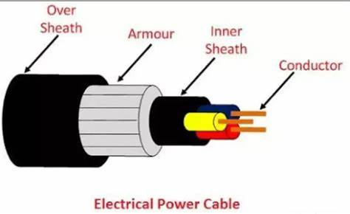The power cable mainly consists of three main components, namely, conductor, dielectric, and sheath. The conductor in the cable provides the conducting path for the current. The insulation or dielectric withstands the service voltage and isolates the conductor with other objects. The sheath does not allow the moistures to enter and protects the cables from all external influences like chemical or electrochemical attack, fire, etc. The main components of electrical power cables are explained below in details.

**CONDUCTOR**

Coppers and aluminium wires are used as a conductor material in cables because of their high electrical conductivity. Solid or number of bare wires made of either copper or aluminium are used to make a power cable.

For a conductor having more than three wires, the wire is arranged around a centre wire such that there are six in the first layer, twelve in the second, eighteen in the third, and so on. The number of wires in the conductors are 7, 19, 37, 61, 91, etc., The size of the conductor is represented by 7/A, 19/B, 37/C, etc., in which first figures represent the number of strands and the second figure A, B, C ,etc., represents the diameters in cm or mm of the individual wire of the conductors.

**INSULATION**

The most commonly used dielectric in power cables is impregnated paper, butyl rubber, polyvinyl chloride cable, polyethylene, cross-linked polyethylene. Paper insulated cables are mostly preferred because their current carrying capacity is high, generally reliable and having a long life. The dielectric compound used for the cable should have following properties.

• The insulator must have high insulation resistance.

• It should have high dielectric strength so that it does not allow the leakage current to passthrough it.

• The material must have good mechanical strength.

• The dielectric material should be capable of operating at high temperature.

• It should have low thermal resistance.

• It should have a low power factor. The cables used for submarine and damp soil should use synthetic dielectrics like polyvinyl chloride, polyethylene, etc. These materials are comparatively lighter and have nonmigratory dielectric. Also, such type of dielectric material has good dielectric strength, low power loss, and low thermal resistance.

**INNERSHEATH**

It is used for protecting the cable from moistures which would affect the insulation. Cable sheath is made up of lead alloy, and these strengths withstand the internal pressures of the pressurized cables. The material used for inner sheath should be nonmagnetic material.

The aluminium sheath is also used in a power cable because it is cheaper, smaller in weight and high mechanical strength than the lead sheath. In oil-filled cables and telephone, cables corrugated seamless aluminium sheath is used because it has better-bending properties, reduced thickness, and lesser weight

**PROTECTIVE** **COVERING**

Lead sheath cables when directly laid down on the ground are damaged by corrosion and electrolyte. For protecting the cables against corrosion layers of fibrous material like paper, hessian, etc., or polyvinyl chloride is used. Layers of fibrous material spread with the waterproof compound to the outside of the electrical cable are called serving.

**ARMOURING**

Armouring is the process in which layers of galvanized steel wires or two layers of metal tape are applied over sheath for protecting it from mechanical damage. The steel wires are normally used for armouring because it has high longitudinal strength. Armouring is also used for earthing the cable. When the fault occurs in the cable (due to insulation failure) the fault current flows through the Armor and get earthed.

**OVERSHEATH**

It gives the mechanical strength to the cables. It protects the cable from overall damage like moisture, corrosion, dirt, dust, etc. The thermosetting or thermoplastic material is used for making over the sheath.

**RESULT**: Network media, cables, and devices and Cable Construction are discussed.

**EXPERIMENT NO- 02**

**AIM**: Demonstration of basic network commands/utilities in Windows.

**OBJECTIVE**: To list commands and execute on the CLI to obtain results such as the IP address and ping among many other results.

**DESCRIPTION** **AND** **EXECUTION**:

**1) Ipconfig**

Ipconfig (Internet Protocol configuration) is among the most common networking tool that allows you to query and show current TCP/IP (Transmission Control Protocol/Internet Protocol) network configuration.

When you type ipconfig at the Command Prompt. You ‘ll see a list of all the network connections your computer is using. Look under ―Wireless LAN adapter‖ if you ‘re connected to Wi-Fi or ―Ethernet adapter if you‘re connected to a wired network.

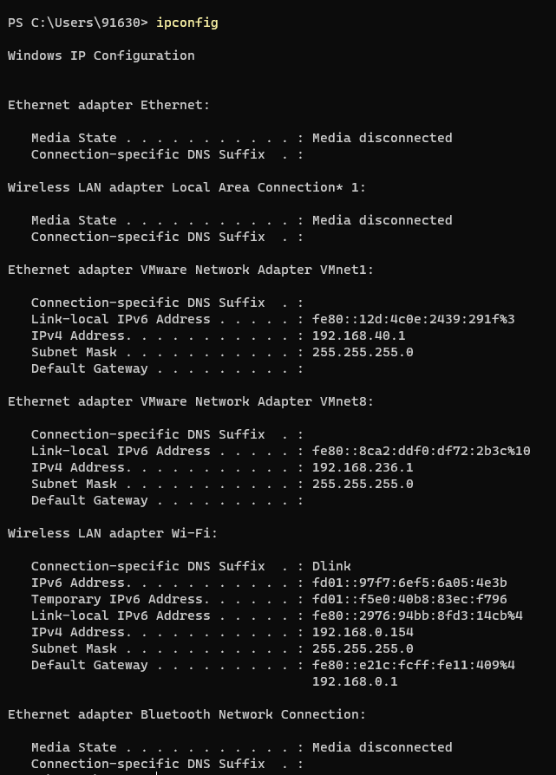

**2) Ipconfig /all**

all – Displays additional information for all network adapters

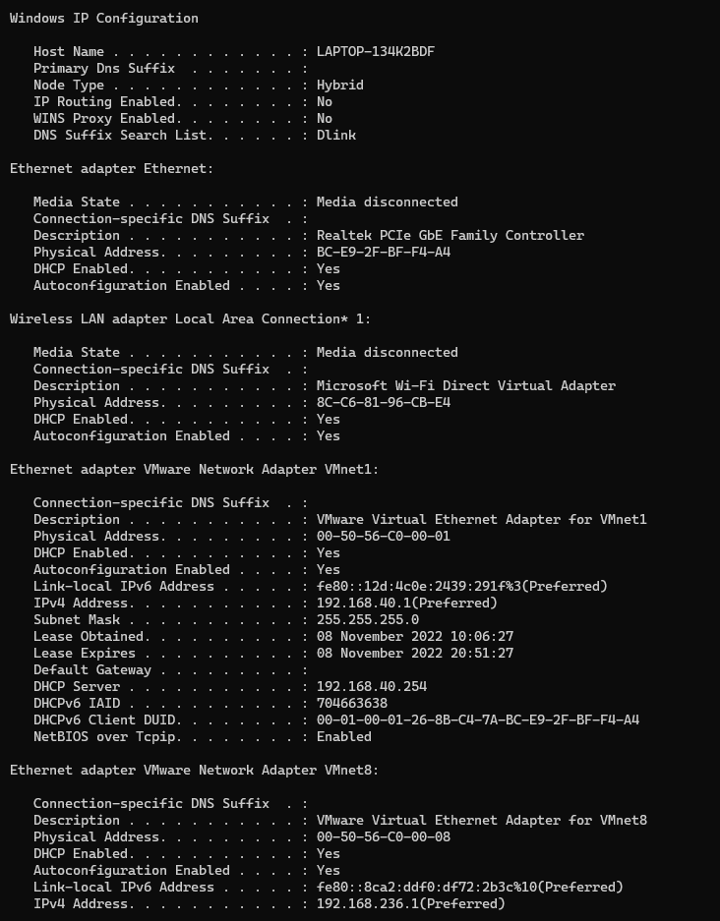

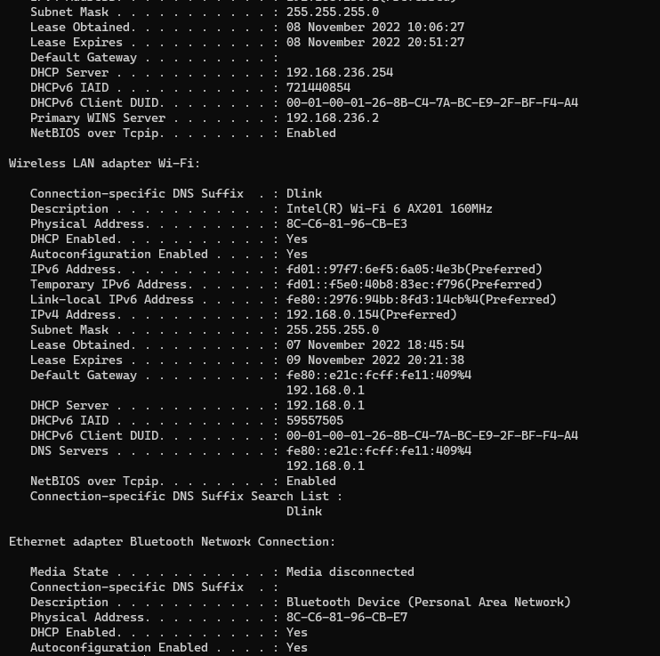

**3) Ping:**

Verifies IP-level connectivity to another TCP/IP computer by sending Internet Control Message Protocol (ICMP) Echo Request messages. The receipt of corresponding Echo Reply messages is displayed, along with round-trip times. Ping is the primary TCP/IP command used to troubleshoot connectivity, reachability, and name resolution.

It is one of the most basic yet useful network commands to utilize in the command prompt application. It tells you whether your computer can reach some destination IP address or domain name, and if it can, how long it takes data to travel there and back again.

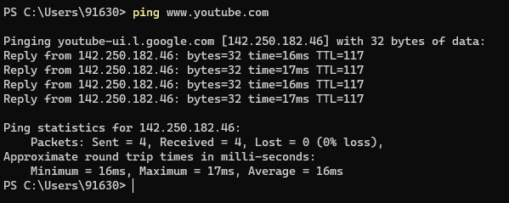

**4) Tracert tracert**

stands for traceroute like ping it sends out a data packet as a way to troubleshoot any network issues you might have, but instead tracks the route of the packet as it hops from server to server

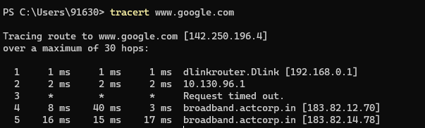

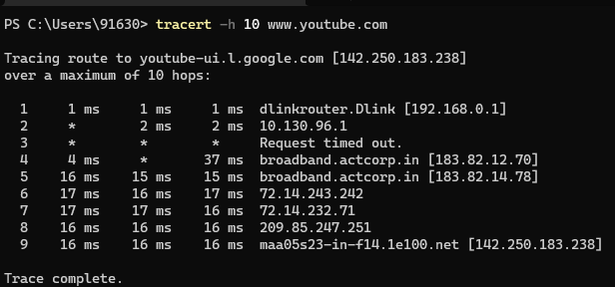

**5) nslookup:**

The nslookup (Name Server Lookup) tool can show valuable details to troubleshoot and resolve DNS-related issues. You can use this command to display the default DNS name and address of the local device, determine the domain name of an IP address or the name servers for a specific node.

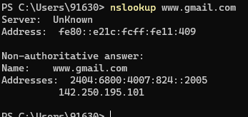

**6) netstat:**

The netstat (Network Statistics) tool displays statistics for all network connections. It allows you to understand open and connected ports to monitor and troubleshoot networking problems for Windows 10 and apps. When using the netstat tool, you can list active network connections and listening ports. You can view network adapter and protocols statistics. You can even display the current routing table and much more.

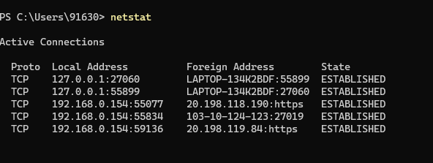

**7) Arp:**

Windows 10 maintains an arp (Address Resolution Protocol) table, which stores IP to Media Access Control (MAC) entries that the system has resolved. The arp tool lets you view the entire table, modify the entries, and use it to determine a remote computer's MAC address. Type the following command to view the current arp table cache on Windows 10 and press Enter: `arp -a'

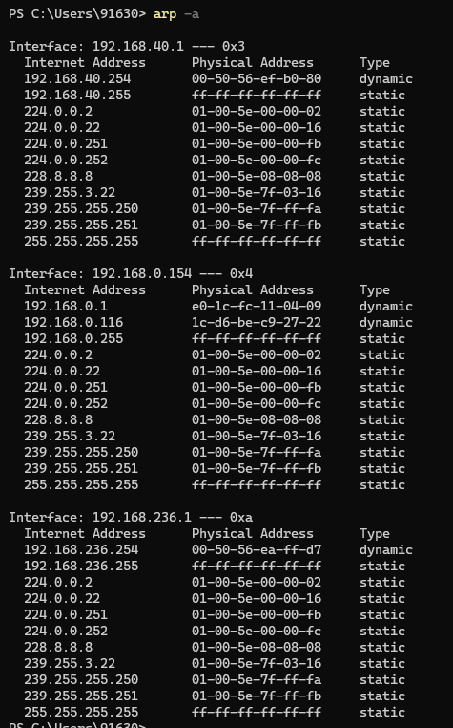

**8) net**

Used for: Displaying available Net switches Command to enter: net

The net command is definitely a versatile one, allowing you to manage many different aspects of a network and its settings such as network shares, users and print jobs, as just a few examples.

Running just net won ‘t do much, but it will present you with a list of all the switches that are available. These include accounts to set password and logon requirements, file to show a list of open files and sessions to list, or even disconnect, sessions on the network.

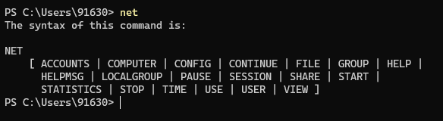

**10) hostname**

The hostname command provides you with an easy way of identifying the hostname that has been assigned to your Windows device.



**RESULTS:**

Ipconfig, ping, tracert, nslookup, netstat, arp, net, hostname and some other commands have been executed and the results have been displayed

**EXPERIMENT NO- 03:**

**AIM:** PC Network Configuration.

**OBJECTIVE:** To demonstrate PC Network Configuration.

**ALGORITHM:**

1. Start

2. Connect to the internet

3. Gather TCP/IP configuration information

4. Record IP address, Subnet Mask and Default gateway for the computer

5. Compare TCP/IP information with other computers

6. Check additional TCP/IP information

7. End

**DESCRIPTION AND EXECUTION:**

**IP Address:**

An Internet Protocol address (IP address) is a numerical label assigned to each device connected to a computer network that uses the Internet Protocol for communication. An IP address serves two main functions: host or network interface identification and location addressing.

Internet Protocol version 4 (IPv4) defines an IP address as a 32-bit number.

IPv4 Classes:

There are 5 classes of IPv4 addresses:

1. ClassA:

The first bit of the first octet is always set to 0 (zero). Thus the first octet ranges from 1 – 127. Class A addresses only include IP starting from 1.x.x.x to 126.x.x.x only. The IP range 127.x.x.x is reserved for loopback IP addresses.

The default subnet mask for Class A IP address is 255.0.0.0 which implies that Class A addressing can have 126 networks (27 -2) and 16777214 hosts (224 -2).

1. ClassB:

An IP address which belongs to class B has the first two bits in the first octet set to 10. Class B IP Addresses range from 128.0.x.x to 191.255.x.x. The default subnet mask for Class B is 255.255.x.x. Class B has 16384 (214) Network addresses and 65534 (216 -2) Host addresses.

1. ClassC:

The first octet of Class C IP address has its first 3 bits set to 110.

Class C IP addresses range from 192.0.0.x to 223.255.255.x. The default subnet mask for Class C is 255.255.255.x.

Class C gives 2097152 (221) Network addresses and 254 (28 -2) Host addresses.

4)ClassD:

Very first four bits of the first octet in Class D IP addresses are set to 1110.

Class D has IP address range from 224.0.0.0 to 239.255.255.255. Class D is reserved for Multicasting. In multicasting data is not destined for a particular host, that is why there is no need to extract host address from the IP address, and Class D does not have any subnet mask.

1. ClassE:

This IP Class is reserved for experimental purposes only for R&D or Study. IP addresses in this class ranges from 240.0.0.0 to 255.255.255.254. Like Class D, this class too is not equipped with any subnet mask.

**DESCRIPTION AND EXECUTION:**

Network Configuration:

Open Control Panel:

Open Network and Internet:

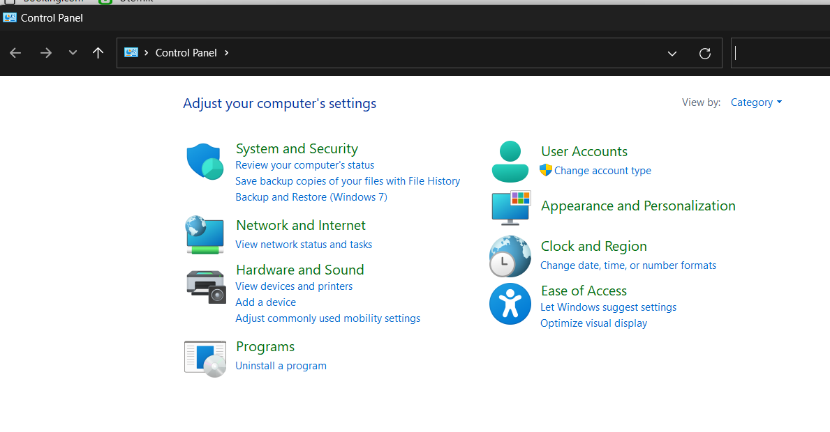

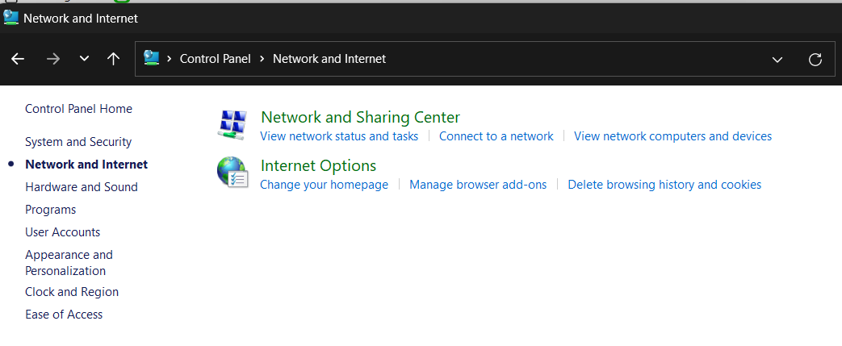

Open Network and Sharing Center:

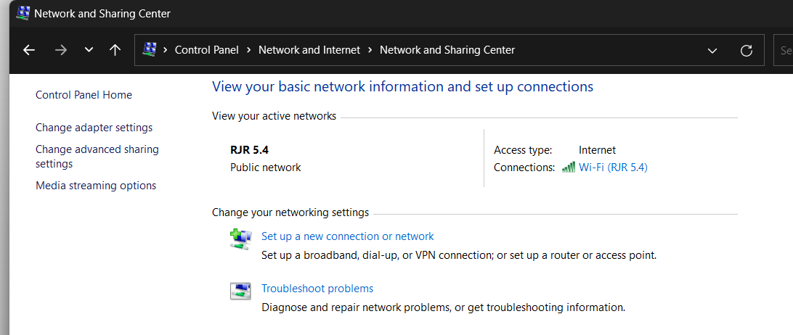

Go to Connection (Wi-Fi or LAN)

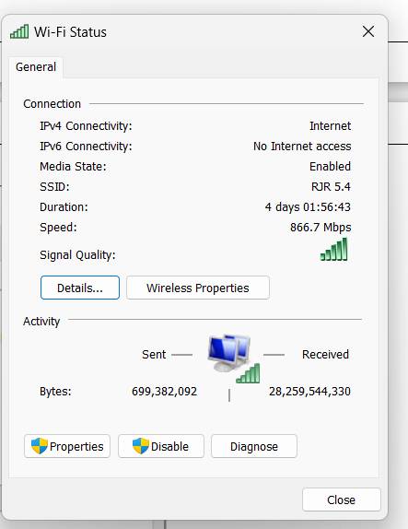

Details:

The IP address, Subnet mask and default gateways can be obtained here.

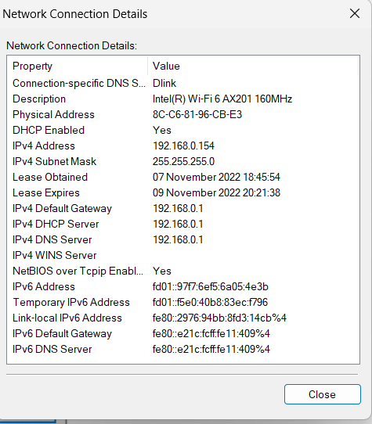



Wireless Properties:

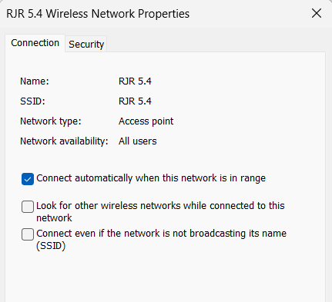

Wi-Fi Properties:

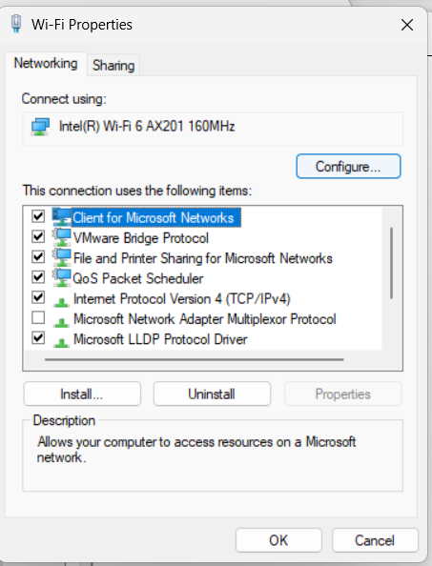

Internet Protocol Version 4 (TCP/IPv4):

The IP address and DNS server addresses can be set manually:

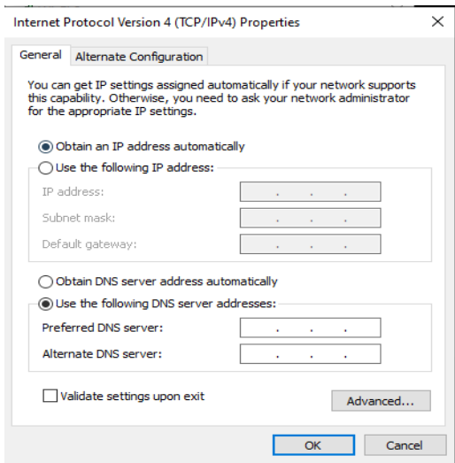

**RESULTS**: IP classes are studied and PC network configuration info is noted.